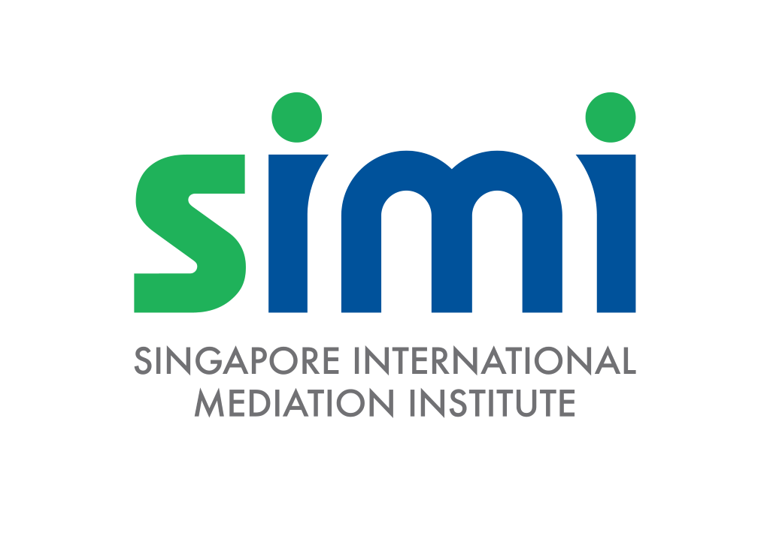

Singapore International Mediation Institute (SIMI)
Registered Training Program (RTP)

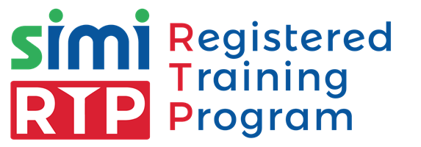

APPLICATION FORM
Version 3.0

TEMPLATE VERSION CONTROL
Version | Effective Date | Changes | Author
1.0 | 2018 | Original | SIMI
2.0 | May 2021 | - Further Guidance included.  - Application Checklist and new section (Public Access to Information) introduced. | SIMI
3.0 | Jul 2024 | - Cheque payment option is removed and included other payment methods acceptable at SIMI. | SIMI

Hello,

Thank you for upholding standards of mediation and your interest in wanting to join SIMI as a partner organisation.

This pack contains (i) information about the SIMI RTP Accreditation (pages 4 to 8); and (ii) the application form for the SIMI RTP Accreditation (from page 10).

TABLE OF CONTENTS

A. INFORMATION ABOUT THE SIMI RTP 5
B. ORGANISATION DETAILS 10
C. MEDIATION TRAINING COURSE 12
D. PUBLIC ACCESS TO INFORMATION 17
E. DECLARATION OF CONFLICT OF INTEREST 18
F. CONSENT 18
FOR OFFICIAL USE ONLY 19
APPLICATION CHECKLIST FOR RTP APPLICATION 20

You can refer to the above table of contents to conveniently locate each section of this document.

We hope to welcome you into the family soon!

Best regards,
The SIMI Team

Information about the SIMI RTP

About the SIMI RTP Accreditation

  - The SIMI Registered Training Programme (SIMI RTP) Accreditation scheme is designed for organisations that intend to offer a mediation training and assessment course leading to participants obtaining internationally recognized accreditation as a mediator.

  - Any organisation may apply to have their mediation training and assessment course accredited as a SIMI RTP. There is no requirement for the organisation to be based, located, or incorporated in Singapore.

  - The SIMI RTP branding allows your organisation’s mediation course to be recognized globally worldwide as a curriculum of quality.

Benefits of the SIMI RTP Accreditation

  - Organisations that are SIMI RTP accredited may submit names of individuals to become accredited at the following tier(s) under the SIMI Credentialing Scheme:
- SIMI Accredited Mediator Level 1 only.

Note: This means that SIMI RTPs will not be able to submit names of individuals to become SIMI Accredited Mediator Level 2, SIMI Accredited Mediator Level 3, or SIMI Certified Mediator. However, an organisation may apply to be both a SIMI RTP as well as a SIMI Registered Service Provider (SIMI RSP). See section A, paragraph 3 below for further illustration.

  - Listing on the SIMI website and use of the SIMI Registered Training Program (SIMI RTP) logo.

  - Highly customised, detailed and independent audit report prepared by SIMI to capture the SIMI RTP essential information.

  - Regular servicing by SIMI to ensure future iterations of the SIMI Mediation Training course remain consistent and relevant.

Comparison of the SIMI RTP Accreditation in relation to other SIMI Partner Schemes:

The following provides a summary of each partner tiers’ general wants/needs:

 | SIMI RTP | SIMI RSP | SIMI QAP
I want to run trainings. | √ |  | √
I want to provide mediation services only. |  | √ | √
I want to be able to assess experienced mediators. |  |  | √

Application Process
  - The SIMI RTP Application process is comprised of a combination of the following stages:

- Stage 1: Review of the Application Form and any supporting document(s)

The submitted application will undergo an initial review process by the SIMI Team. This process is expected to take place between six (6) to eight (8) weeks.

- Stage 2: Discussion between the Applicant and a SIMI Representative

In certain cases, the Applicant may be invited to have a meeting with a SIMI Representative for further clarifications sought on the Application.

- Stage 3: Audit

As part of the review process, a SIMI representative may sit in on the Applicant’s course as an Auditor. Any such audits would be communicated to the Applicant beforehand. These audits will also be recorded in a Report that will be provided to the Applicant.

  - Applicants should ensure that the contact email address provided on the Application Form is active and checked regularly for all correspondence from SIMI relating to the application.

  - SIMI welcomes applications throughout the year.

  - An organisation may only have (1) one application reviewed at a time. Multiple submissions may affect the processing of the application.

Submission of Application to be SIMI RTP Accredited

By Email: Applicants are to submit the completed Application Form together with any supporting documents to the SIMI Team at members@simi.org.sg with the subject “SIMI RTP APPLICATION [APPLICANT NAME]”.

Application Results

  - All application results will be communicated in writing by email.

  - In the case of a successful result, the Applicant will be granted SIMI RTP status, subject to (i) the payment of the applicable fees (see Section 7), and (ii) acceptance of the terms and conditions of a SIMI RTP, which will be sent with the notification email.

  - The SIMI RTP status will be valid for three (3) years from the date of approval and will be subject to renewal at the end of each three (3) year period.

In the case of an unsuccessful result, the Applicant may make a re-submission or new submission after a waiting period of three (3) weeks.

SIMI RTP Fees Payable

The fees payable for the SIMI RTP Accreditation is set out in the table below.
S/N | FEE DESCRIPTION | AMOUNT (SGD)
 | Application Fee  This is an administrative fee that is charged for reviewing each application. | 750.00
 | SIMI RTP Annual Fee  This is an annual fee that is payable each year, starting from the date of successful application. | 2000.00

  - Payment can be made by the following methods.

    - PayNow to UEN No. 201420752C (for individuals/businesses which have an account with a participating bank in Singapore).

    - PayPal via https://www.paypal.com/paypalme/thesimichat
    - Payment by electronic fund transfer is to be made to the following bank account. Please send us an email at admin@simi.org.sg with proof of payment after you have successfully made the transfer:

Account Name: Singapore International Mediation Institute Limited CitiBank Account: 0-860317-001

Currency: SGD

Bank Name: Citibank, N.A. Singapore

Bank Address: 3 Changi Business Park Crescent, 07-00, Singapore 486026

SWIFT Code: CITISGSG

Bank Code: 7214
Branch Code: 001

For overseas transfers, please quote 'OUR' and take note that you will bear all transaction fees. Please request your bank (as necessary) to charge such fees to you, so that SIMI receives the full amount invoiced. These fees include the charges levied by the sending bank and any charges applied by intermediary (correspondent) banks.

Other Notes

  - SIMI RTPs are part of the wider SIMI Partner Scheme and will be required to recognise the accreditation and/or certification of SIMI Mediators by other SIMI Partners. This is to provide SIMI Mediators greater flexibility in choosing where to offer their mediation services as well as more options in acquiring mediation experience.

About this Application Form

  - The document is intended for Applicants to provide SIMI with information about your organisation’s programme, which would go towards fulfilling the SIMI RTP requirements. This form has been categorised into the following sections:

- Section B requests for further information about your organisation and details of the administrator of the relevant programme (i.e., the person SIMI should be in contact with, with regards to the application).
- Section C requests for an overview of the relevant mediation training course, such as the course lesson hours, curriculum, trainers, and assessment methodology.
- Section D highlights where the public can gain access to information about the assessment criteria for SIMI Accredited Mediators.
- Section E covers the declaration of any conflict of interests, as well as any other generally relevant information.

ORGANISATION DETAILS (“the Applicant Organisation”)
- Name of Organisation

Click here to enter text.
- Country of Incorporation

This is for administrative records purposes only. Incorporation outside of Singapore will not prejudice your organization’s RTP application.

Click here to enter text.
- Company Details
- Applicant Company Address

Click here to enter text.

- Applicant Company Registration Number

Click here to enter text.

- Applicant Company Contact Number

Click here to enter text.

- Applicant Company Email

Click here to enter text.
- Contact Personnel for this Application

Please ensure that these contact details, especially the email address, are active and checked regularly. All correspondence relating to the application will be sent to this email.
- Contact Person’s Name

Click here to enter text.

- Contact Person’s Designation

Click here to enter text.

- Contact Person’s Contact Number

Click here to enter text.

- Contact Person’s Email

Click here to enter text.
- Email for SIMI Partner Account Creation (for successful applicant)

Successful applicants will be provided with an account to log-in to SIMI’s website to manage their SIMI Mediators.

Click here to enter text.

MEDIATION TRAINING COURSE

What is the name of the Mediation Training Course?

Click here to enter text.

- Lesson Hours

There should be a minimum of forty (40) lesson hours. This includes all time allotted for theory and practical lessons but does not include any break or assessment time. Please include a break-down of the lesson hours (e.g., theory, practical etc.).

You may wish to include relevant supporting documents for your responses to facilitate the review of your application.

  - What is the total Number of Curriculum Hours in the Mediation Training Course?

The total number of hours includes both break hours and lesson hours

Click here to enter text.
  - What is the Total Number of Break Hours / Minutes provided to delegates when they attend the Mediation Training Course?

Click here to enter text.
  - What is the Total Number of Lesson Hours in the Mediation Training Course?

Lesson hours include presentations, lectures, roleplay exercises and review of the roleplay exercises. Registration and other administrative exercises should not be included.

Click here to enter text.

- Overview of Curriculum

Certain topics are required to be taught to the delegates to ensure competency of the delegates in mediation post-course. Please map your course topics to SIMI’s topic headers.

You may wish to include relevant supporting documents for your responses to facilitate the review of your application.

Required Topic (1): Overview of Mediation Legislation in Singapore
- Mediation-specific laws and rules
- Legal and/or ethical requirements for mediators

Description of Course:

Click here to enter text.

Required Topic (2): Conflict Resolution Theory
- Escalation of conflict
- Models of conflict resolution
- Interest-based negotiation and position-based negotiation

Description of Course:

Click here to enter text.

Required Topic (3): Mediation Theory
- Role of a mediator
- Role of the mediation advocate
- Outline of the mediation process
- Styles of mediation and mediators
- Benefits of the mediation process
- Assessing suitability of cases for mediation
- How to prepare for a mediation

Description of Course:

Click here to enter text.

Required Topic (4): Mediation Techniques
- Communication skills
- Problem solving skills
- Process skills

Description of Course:

Click here to enter text.

Additional Topic (where applicable): Click here to enter text.

Description of Course:

Click here to enter text.

- Mediation Training Course Trainer Details

Trainers must have sufficient experience and competence in training and/or coaching mediators. This can be demonstrated either through external accreditation or prior experience. By submitting the names of your trainers here, your organisation is endorsing the experience and competency for each trainer.*

*Note: If there are changes to the stated panel of trainers at any point in time of the application and/or post formal approval of the application, the applicant or SIMI Partner must update SIMI.

You may wish to include relevant supporting documents including the most updated training CVs for all your trainers for the course to facilitate the review of your application.

  - Who are the Trainers for the Mediation Training Course? What are their Qualifications & Experiences?

Click here to enter text.

  - How are Trainers appointed to train for the Mediation Training Course?

Click here to enter text.

- Participant Feedback Process of Mediation Training Course

Please include details of how feedback is collected from participants with regard to the trainer(s) and/or the process of training, including information about the record process and follow-up process.

Click here to enter text.

- Course Assessment Details

Please provide all assessment details of your mediation training course i.e. how are participants being assessed to be deemed competent. There should be a reasonable weightage between theoretical and practical components in the assessment.

Click here to enter text.

- Course Assessor Details

Assessors must have sufficient experience and competence in evaluating and/or judging mediators. This can be demonstrated either through external accreditation or prior experience. By submitting the names of your assessors here, your organisation is endorsing the experience and competency for each assessor.*

*Note: If there are changes to the stated panel of assessors at any point in time of the application and/or post formal approval of the application, the applicant or SIMI Partner must update SIMI.

To avoid conflict of interest, the pool of trainers (see previous section) should also not overlap with the pool of assessors.

You may wish to include relevant supporting documents including the most updated training CVs for all your assessors for the course to facilitate the review of your application.

  - Who are the Assessors for the Mediation Training Course? What are their Organisational Affiliations?

Click here to enter text.

  - How are Assessors appointed to assess for the Mediation Training Course?

Click here to enter text.

  - How are Assessors briefed to prepare them to assess the candidates?

Click here to enter text.

PUBLIC ACCESS TO INFORMATION

- Where can members of the public view information about the Mediation Training Course?

Please describe where the information for your course will be accessible by the general public.

Click here to enter text.

DECLARATION OF CONFLICT OF INTEREST

This section considers whether there are any conflicts of interest that need to be resolved between the applicant and SIMI.

Please provide details for any of the following that may apply to your organisation. Please indicate “NA” for those that do not apply.

Issue | Applicant’s Declaration  (Y/NA)
Does anyone in your organisation hold, or has held, a position on SIMI’s board of directors? | Click here to enter text.
Does anyone in your organisation hold, or has held, an employment position in SIMI? | Click here to enter text.
Has your organisation ever provided any form of financial support to SIMI (e.g., donations, grants, funding for events)? | Click here to enter text.
Has your organisation ever received any form of monetary compensation from SIMI? | Click here to enter text.
Is anyone in your organisation related to a member of SIMI’s current board of directors or current employee? | Click here to enter text.

Comments

If there is a “Y” indicated for any of the above, please include further details here.

Click here to enter text.

CONSENT

By submitting this application form, I hereby acknowledge that I am authorised to represent the organisation listed on this form and I declare that all information provided are true and accurate to the best of my knowledge. I undertake to inform SIMI as soon as reasonably possible should I be aware that any of the information previously provided on this application form is no longer true. I understand and accept that SIMI has the right to reject or revoke an application should any information provided on this form be found to be untrue. I consent to SIMI using the personal data provided on this form to contact me for the purposes of processing this application.

Click here to enter text. | Click here to enter text.
Name, Designation and Signature | Date

FOR OFFICIAL USE ONLY

The SIMI Board of Directors has reviewed the disclosure of interests above and have come to the following decision:

The application should not be accepted. | ☐
The application may be accepted, provided that there is no change to the declaration above. | ☐

APPLICATION CHECKLIST FOR RTP APPLICATION

Complete your submission for SIMI RTP Accreditation application by making sure you

Submit the SIMI RTP Application Form;

Submit the relevant supporting document(s), where applicable;

Make SGD 750.00 application fee payment.

Recommended list of supporting documents:

SECTION | RECOMMENDED SUPPORTING DOCUMENTS | CHECKBOX
Mediation Training Course Curriculum | - Program of the course  - Previous program - if your organisation has run it before); or  - A draft program of the course (if you have yet to run it); | ☐
Mediation Training Course Curriculum | - Lecture slides and sample roleplay exercises | ☐
Mediation Training Course Curriculum | - Relevant course feedback forms | ☐
Mediation Training Course Trainer Details | - CVs of the trainers; | ☐
Mediation Training Course Trainer Details | - Template of feedback forms that participants will complete to give feedback on trainers. | ☐
Mediation Training Course Assessment Details | - CVs of the assessors; | ☐
Mediation Training Course Assessment Details | - Assessment rubric of the written and practical assessment | ☐
Mediation Training Course Assessment Details | - Briefing process for assessors | ☐

Note: This checklist of supporting documents is meant to be a guide to assist Applicants in their initial submission for the SIMI RTP Accreditation. Incomplete submission(s) of the above supporting documents will not affect the processing of the application.

